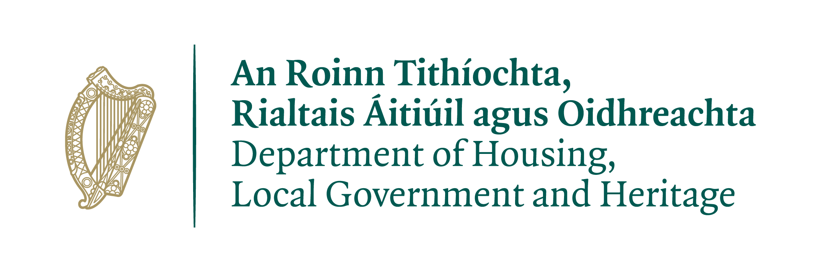

Ireland’s Tentative List of World Heritage Sites Application Form

(Privacy Statement)

The Department of Housing, Local Government and Heritage is the Government Department responsible for housing and water, for physical and spatial planning, for local government, for weather forecasting and for built and natural heritage.

The Department is committed to protecting and respecting your privacy. This privacy statement explains how the Department, as the Data Controller, will process the personal data provided to it in respect of applications for Ireland’s Tentative List of World Heritage Sites; how that information will be used, and what rights you may exercise in relation to your personal data.

Purposes of the processing
The Department will use your data in order to appraise your application form to decide whether the site has outstanding Universal Value as required for World Heritage Sites. The Department will not process your personal data for any purpose other than that for which it was collected.

Profiling
The Department will not use any personal data collected from you in respect of the Tentative List of World Heritage Sites for automated decision-making, or for profiling purposes.

Lawfulness of processing
This processing of your personal data is lawful under Article 6 (1)(a).

Security of your personal data
The Department implements appropriate technical and organisational measures to protect your information from unauthorised access. However, despite these efforts, no security measures are perfect or impenetrable, and no method of data transmission can be guaranteed against any interception or other type of misuse. In the event that your personal data is compromised as a result of a breach of security, the Department’s Breach Management policy and procedures will be implemented.

Recipients of the data
Personal data may be exchanged with other Government Departments, local authorities, agencies under the aegis of the Department, or other public bodies, in certain circumstances where this is provided for by law. Personal data may be shared with an Expert Advisory Group and/or UNESCO and its Advisory Bodies for the purposes of assessing Tentative List applications.

Cross-border Data Transfers
The Department will not transfer personal data collected in respect of the application to any country or international organisation outside the EU/EEA.

How long will your data be kept?
The Department will only retain your personal data for as long as it is necessary for the purposes for which it was collected and processed.
In line with legislative and business requirements, the data retention period for your personal data, in this instance, is two years.

Your rights
The Department's Data Protection Policy, which sets out how we will use your personal data, as well as providing information regarding your rights as a data subject (including details regarding right of access, right to rectification, right to erasure, right to restriction of processing, right to object), is available on our website. The policy is also available in hard copy upon request.

If you consider that your rights have been infringed, you have the right to complain to the Irish Data Protection Commissioner (www.dataprotection.ie), and you have the right to seek a judicial remedy.

Contacting Us
If you require further information, or wish to access your personal data, please contact the Department’s Data Protection Officer, details below:

Data Protection Officer,
Department of Housing, Local Government and Heritage,
Newtown Road,
Wexford
Email: data.protection@housing.gov.ie

